**Quantitative analysis on diffusing applicators for cylindrical light** **transmission**

V.G. Truong1 and H.W. Kang1,2

1Department of Biomedical Engineering, Pukyong National University, Busan, Korea

2Center for Marine-Integrated Biomedical Technology, Pukyong National University, Busan, Korea

[**wkang@pukyong.ac.kr**](mailto:wkang@pukyong.ac.kr)

**Abstract**

Optical diffusers have been developed to a uniform and isotropic light irradiation for medical applications, including photodynamic therapy (PDT) and photocoagulation. In this study, we designed a system to make cylindrical fiber and evaluated effect of several factors on the quality of cylindrical fiber. In addition to spatial emission from the diffuser was evaluated by goniometric measurements. The proposed diffusing fiber fabrication system may be a feasible model to optimize the quality emission of cylindrical fiber used in biomedical applications.

**Background**

Lasers have been used for a variety of medical applications, such as tissue ablation, blood coagulation, surgical resection, and optical imaging [1]. Cylindrical light diffusers are commonly used for photodynamic therapy, interstitial photocoagulation, and interstitial hyperthermia [2]. However, to precisely control the amount of optical energy from the fiber is very critical in determining therapeutic outcomes. Non-homogenous light irradiation can hardly achieve uniform light distribution in tissue, which may cause unfavorable coagulation and even carbonization during thermal treatment [1].We developed a new technique to fabricate diffusing optical fibers by a laser system. The transmitted light could be diffused by varying the critical angles inside the fiber to reduce the probability of the total internal reflection and by regulating fabrication power to control ablation depth. The fabricated fiber tips were quantitatively evaluated by using a customized goniometer to characterize the spatial uniformity of light propagation light propagation.

**Methods**

Figure.1 shows a set-up for laser micro-fabrication of a diffusing optical fiber. The bean from a laser system (λ = 10.6 µm) had 3-mm diameter and was expanded to approximately 7.5 mm by using a combination of concave lens (f1 = −25 mm) and convex lens (f2 = 75 mm). Then, the expanded beam was focused on the fiber surface by another convex lens (f3 = 25 mm). A 600-µm multimode fiber (N.A=0.5, Thorlabs Inc., Newton, New Jersey, USA) was used to create the optical diffuser and the total length of the diffusing tip was 10 mm. The optical fiber was positioned in a fiber holder that was fixed at a motorized-stage system to position the fiber while the translational stage moved the fiber along the x-axis direction. In addition to avoiding excessively localized energy at proximal fiber, the convex lens was moved along the y- axis.

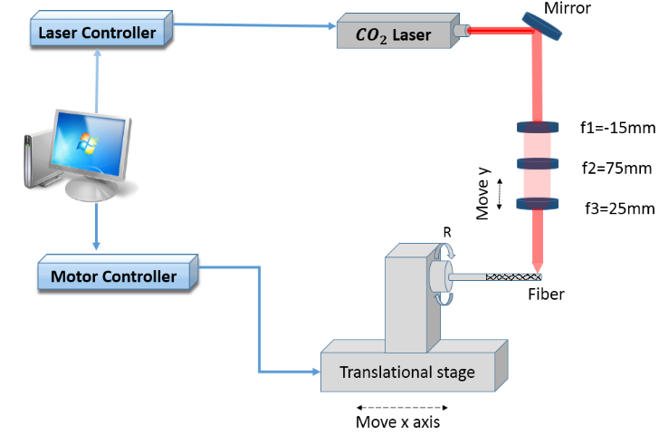

Figure 1. Diffusing fiber fabrication set-up(R : rotation stage).

To obtain surface patters, the both translational and rotational motions were synchronized with each other. The fabrication angle between the fiber axis and the groove path was adjusted and changed in this experiment to avoid any overlapping between two consecutive grooves during the fabrication process. Laser power was also modulated to control the depth of each groove in an optical fiber. All the motorized-stages were driven by a motion control system in conjunction with LabView software (National Instrument Corp., Austin, Texas, USA).

To validate the uniformity of micromachining on the fiber surface, diffusing tips were imaged by using scanning electron microscope (SEM). A customized goniometer was also employed to quantify the spatial distribution of the normalized light intensity from the fiber. The beam from the HeNe laser (λ = 632 nm, Thorlabs Inc., Newton, New Jersey, USA) was coupled into the ﬁber via a micro-objective lens. For longitudinal radiance emission measurements the detector was moved by 0.05 mm/s along the fiber and was placed in front of the fiber and distance 0.3mm to limit the diffusive light. The detector was rotated with axis in a vertical or horizontal located fiber, for polar emission measurement. All experiments were executed in free space.

**Results and Discussion**

Figure. 2(a) shows a microscopic image of the fiber surface fabricated at 45° with power level (7.5%) of laser system. The image indicated no overlapping between the patterns on the fiber surface. For quantitative evaluations on light diffusion, Figure. 2(b) exhibits spatial distribution of the normalized intensity from the diffuser tip in conjunction with HeNe laser. The intensity distribution revealed an asymmetric and relatively less homogeneous profile of the light distribution due to diffusing patterns. It was noted that the optical power was mainly concentrated in the range from 2.5 mm to 8 mm, accounting for 85% of the transmitted power.

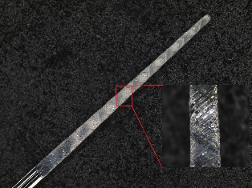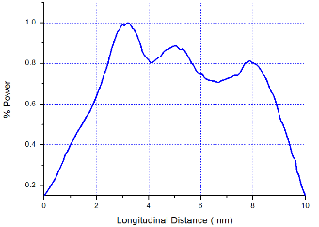

1. (b)

Figure.2 (a) Microscopic image of fiber surface and (b) longitudinal emission profiles.

Figure.3 demonstrates the impact of fabrication power on the cylindrical emission in a fiber. Four fiber samples were evaluated under the same experimental conditions (diffusing length 10 mm and fabrication 30°) but with different fabrication power levels (7%, 7.5%, 8% and 8.5 %). The results showed that the fiber fabricated at 8.5% power achieved the peak intensity at the position 2 - 3 mm and the intensity shifted toward the distal end of the diffuse with the power decreasing. As groove patterns on the surface reached the proximity of the fiber core strong light emission occurred at the proximal end of the fiber. With the fabrication powers of 7.5% and 7%, strong light emissions were located along relatively longer fiber segments. Conceivably, with the combination of the changed angles between the fiber axis and the groove path, the fabrication power expects that cylindrical fiber optic light diffusers may have be isotropic and uniform light distribution.

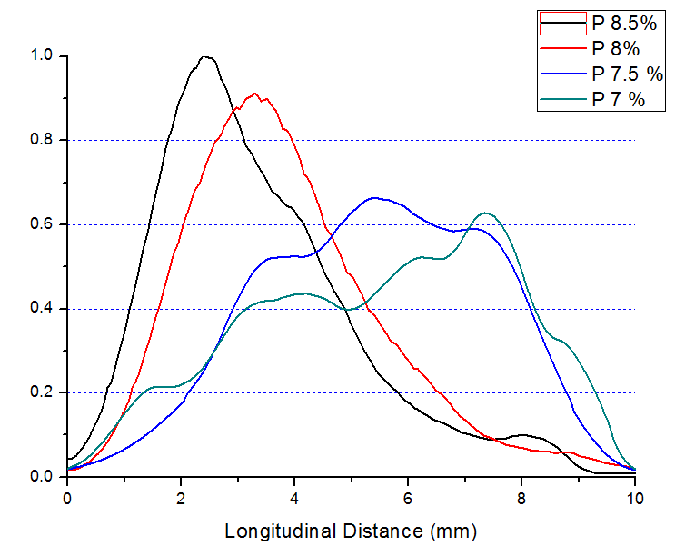

Figure.3 Longitudinal emission profiles for four different fabrication power levels.

**Acknowledgements**

This research was supported by Basic Science Research Program through the National Research Foundation of Korea (NRF) funded by the Ministry of Education, Science and Technology (NRF-2014R1A1A2060112) and a grant from Marine Biotechnology Program (20150220) funded by Ministry of Oceans and Fisheries, Korea

**References**

1. Trung Hau Nguyen, Yun-hee Rhee, Jin-chul Ahn, and Hyun Wook Kang,” Circumferential irradiation for interstitial coagulation of urethral stricture”, optics express, Vol. 23, No. 16, 2015.
2. L. M. Vesselov, W. Whittington, and L. Lilge, “Performance evaluation of cylindrical fiber optic light diffusers for biomedical applications,” Lasers Surg. Med. 34(4), 348–351 (2004).